Dummy Sites:

<https://www.lambdatest.com/selenium-playground/>

<https://ecommerce-playground.lambdatest.io/>

My Repo on GitHUB: <https://github.com/sainiashu/lt_python_sel_pytest>

basic commands:

* Py.test: To run all tests
* Pytest –rA: Give you a detailed information about the executions.
* Pytest – v – rA : -v is used to get the more information about the test in the verbosed mode
* Pytest – v –rA “test location”

There are multiple ways to run test in pytest

* Individual test:
  + pytest -v -rA C:\Users\lenovo\PycharmProjects\lt_python_sel_pytest\DemoSecTest\test_search.py
* Tests under python packages
* Pass the python package name as an argument in the command line
  + pytest –v rA DemoSectest
* Also we can pass the python packages as as argument in the pytest command to run multiple packages as
  + pytest –v rA DemoSectest DemoFirstTest
* We can run the tests with the match string in the test name . it will execute all the tests those are fulfill the conditions and run the tests. Also reports shows the deselect tests details as well
* Use “-k” in the pytest command to match the string in all the tests those are fulfill the conditions
* You can run the test inside the python file using the below command:
  + (.venv) PS C:\Users\lenovo\PycharmProjects\lt_python_sel_pytest\DemoSecTest> **pytest -v -rA test_simple_form_demo.py::test_web_form**
* 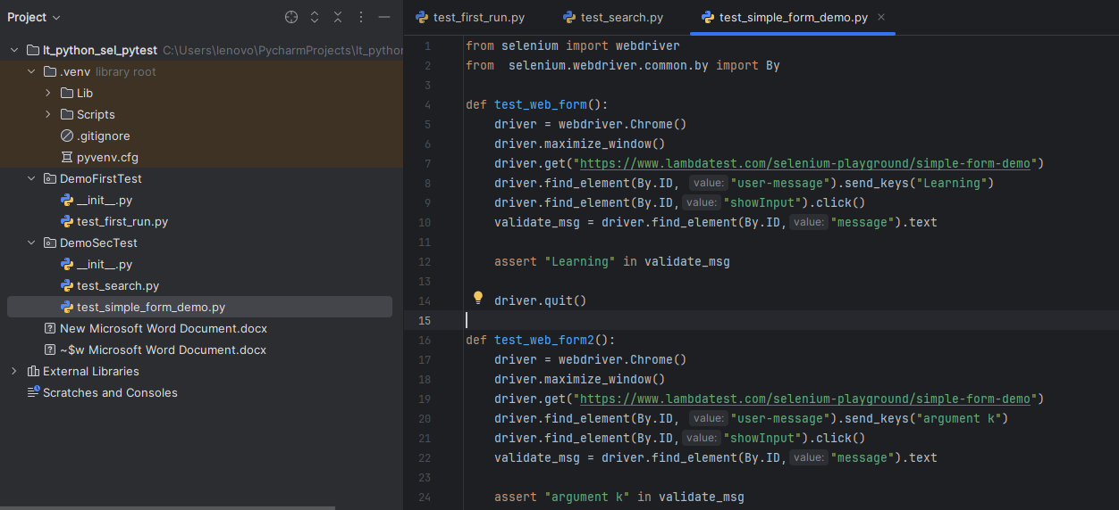

**PYTEST MARKERS**

**There are few inbuilts markers and we can create customized markers**

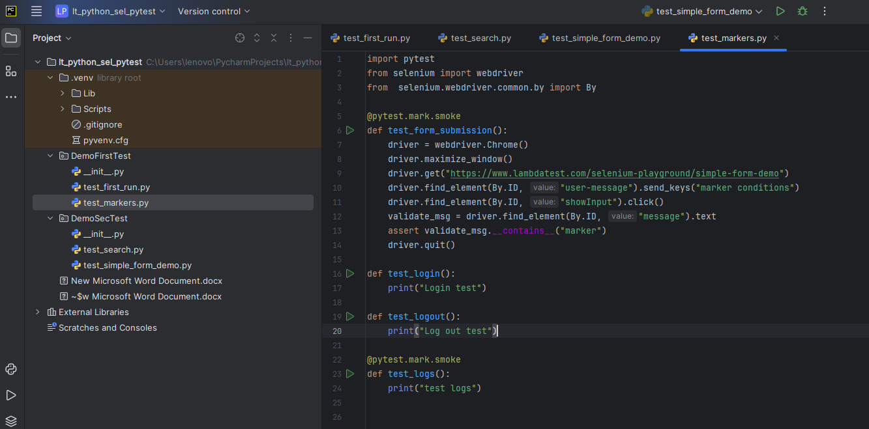

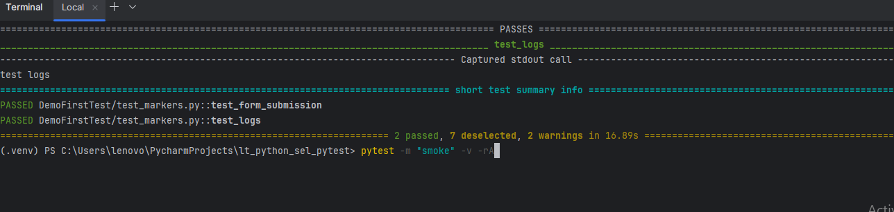

HERE YOU CAN SEE THE WARNINGS IN THE TERMINAL. So if you want to disablethe warnings the n you can write the following command

**pytest -m "smoke" -v -rA --disable-warnings**

**PYTEST.INI**

**We will create a pytest.ini file in the root directory and It works for the entire framework and it is configuration file.**

**pytest–markers : it will shows all the markers inbuilt and user define markers**

* **First we need to add pytest in square bracket “[pytest]** 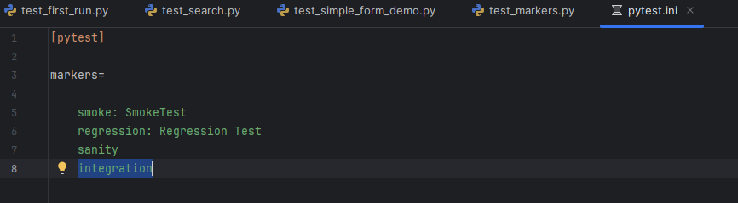
* **Create name “markers=”**
  + **Add custom markers name such as “smoke” also we can add the description here. Please see the screen shot above**
* **Rather than typing the –v –rA repeatedly in the command line we can pass this information in the same pytest.ini file**
* 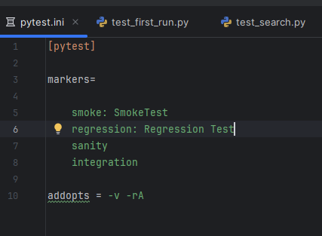

**Also we can use combination of markers and use it our test:**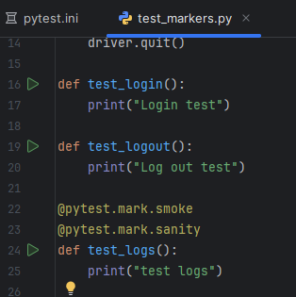

**pytest -m "smoke and sanity"**

**it will execute only 1 test**

**Other Examples**

**Pytest –m “smoke and not sanity”**

**Now it will run 2 test cases**

**Pytest –m “not smoke”**

**It will run all the test those are not smoke markers**

**Pytest -m “smoke or sanity”**

**AS OF NOW WE DEFINE THE FUNTIONS LEVEL**

**NOW WE CAN DEFINE IN THE FILE LEVEL**

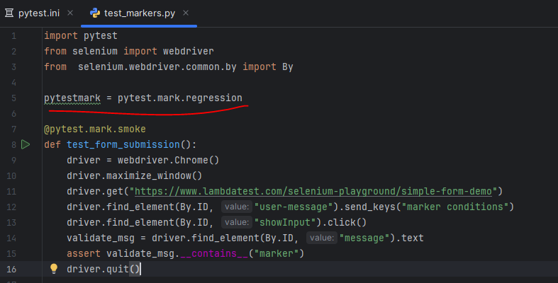

**Pytest –m “regression”**

**Above command run all tests inside the tes_markers.py file because of the following command:**

**pytestmark= pytest.mark.regression**

**IF WE WANT TO ADD MORE MARKERS IN THE FILE LEVEL THEN WE CAN USE THE SQUARE BRACKET “[]” AND PASS MARKER NAME INSIDE THE SQUARE BRACKET**

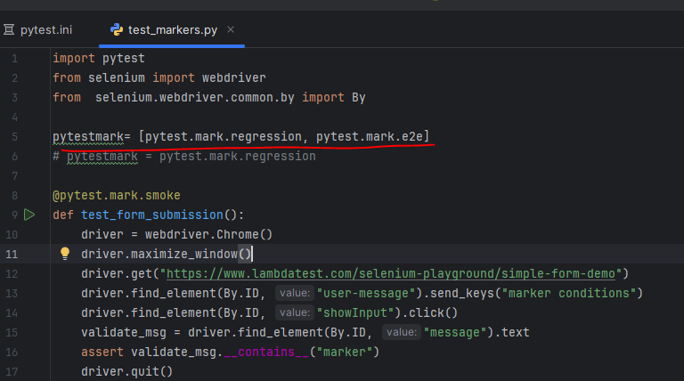

**FIXTURE USAGE**

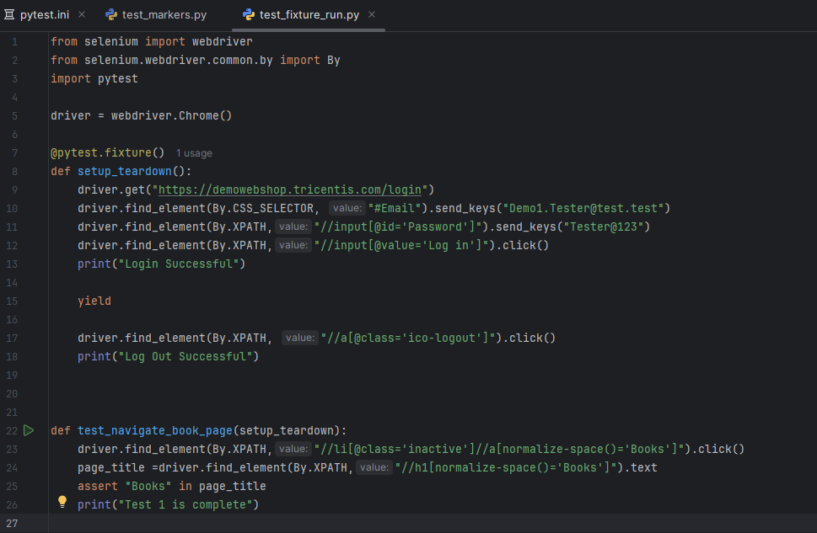

**Execute multiple test using @pytest.fixture()**

**In the below example you can see the that it will first run the setup_teardown function before the actual test run such as test1 and test2**

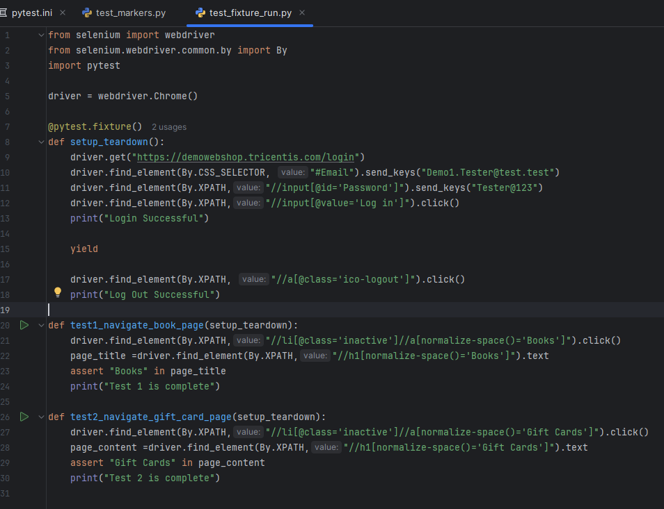

**NOTE: Also you can use the @pytest.fixture(autouse=True) it will use the fixture by default for all the tests in case you forgot to mentioned the setup_teardown fixture function into the test**

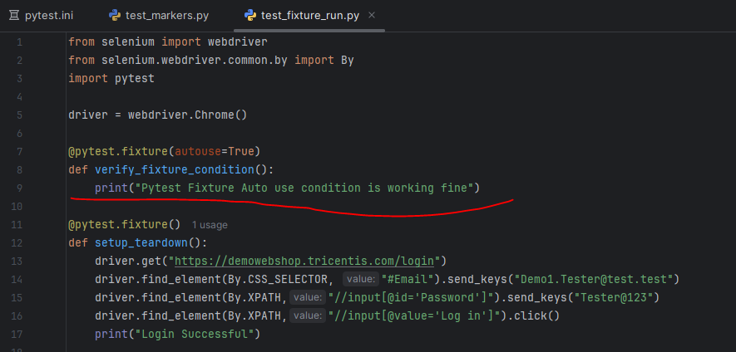

**By default scope of fixture is function. But we can set to class, module, package or session**

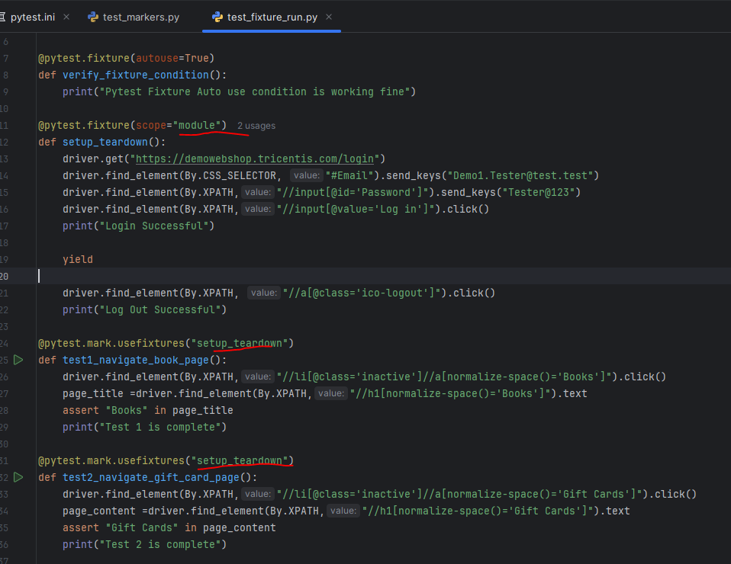

**In the below image we can use the**

**@pytest.mark.usefixtures(“setup_teardown”)**

@pytest.mark.usefixtures("setup_teardown")  
def test1_navigate_book_page():  
 driver.find_element(By.XPATH,"//li[@class='inactive']//a[normalize-space()='Books']").click()  
 page_title =driver.find_element(By.XPATH,"//h1[normalize-space()='Books']").text  
 assert "Books" in page_title  
 print("Test 1 is complete")

**Scope define in module level**

@pytest.fixture(autouse=True)  
def verify_fixture_condition():  
 print("Pytest Fixture Auto use condition is working fine")  
  
@pytest.fixture(scope="module")  
def setup_teardown():  
 driver.get("https://demowebshop.tricentis.com/login")  
 driver.find_element(By.CSS_SELECTOR, "#Email").send_keys("Demo1.Tester@test.test")  
 driver.find_element(By.XPATH,"//input[@id='Password']").send_keys("Tester@123")  
 driver.find_element(By.XPATH,"//input[@value='Log in']").click()  
 print("Login Successful")  
  
 yield  
  
 driver.find_element(By.XPATH, "//a[@class='ico-logout']").click()  
 print("Log Out Successful")

**If we define the fixture scope in function level then it will execute test one by one but always use setup_teardown function which include both login and logout. However, in case of module login and logout done only one time**

**PYTEST PARAMTERIZE**

**PARAMETERIZE TEST WITH ONE DECORATOR**

from selenium import webdriver  
from selenium.webdriver.common.by import By  
  
import pytest  
  
@pytest.mark.parametrize("num1,num2,expected_result",  
 [  
 ("10","20","30"),  
 ("30","20","50"),  
 ("5","5","30"),  
 ])  
  
def test_parameter(num1,num2,expected_result):  
 driver = webdriver.Chrome()  
 driver.get("https://www.lambdatest.com/selenium-playground/simple-form-demo")  
 driver.maximize_window()  
 driver.find_element(By.XPATH,"//input[@id='sum1']").send_keys(num1)  
 driver.find_element(By.XPATH,"//input[@id='sum2']").send_keys(num2)  
 driver.find_element(By.XPATH,"//button[normalize-space()='Get Sum']").click()  
 actual_total =driver.find_element(By.XPATH,"//p[@id='addmessage']").text  
  
 assert actual_total == expected_result,\  
 "Actual vs Expected values does not match"  
 driver.quit()

**PARAMETERIZE TEST WITH TWO DECORATOR**

import pytest  
from selenium import webdriver  
  
from selenium.webdriver.chrome.service import Service as ChromeService  
from selenium.webdriver.firefox.service import Service as FirefoxService  
  
from webdriver_manager.chrome import ChromeDriverManager  
from webdriver_manager.firefox import GeckoDriverManager  
  
@pytest.mark.parametrize("browser",["chrome","firefox"])  
@pytest.mark.parametrize("url",["https://www.lambdatest.com/selenium-playground/simple-form-demo",  
 "https://demowebshop.tricentis.com/"]  
 )  
def test_open_browser(browser,url):  
 if browser == "chrome":  
 driver = webdriver.Chrome(service=ChromeService(ChromeDriverManager().install()))  
 driver.get(url)  
 elif browser == "firefox":  
 driver = webdriver.Firefox(service=FirefoxService(GeckoDriverManager().install()))  
 driver.get(url)  
 else:  
 raise ValueError("Browser not supported")  
  
 driver.maximize_window()  
  
 driver.quit()

**ANOTHER EXAMPLE OF PARAMETERIZATOIN IN PYTEST**

import pytest  
from selenium import webdriver  
from selenium.webdriver.common.by import By  
  
from selenium.webdriver.chrome.service import Service as ChromeService  
from selenium.webdriver.firefox.service import Service as FirefoxService  
# from selenium.webdriver.edge.service import Service as EdgeService  
from selenium.webdriver.edge.service import Service as EdgeService  
  
from webdriver_manager.chrome import ChromeDriverManager  
from webdriver_manager.firefox import GeckoDriverManager  
# from webdriver_manager.microsoft import EdgeChromiumDriverManager  
from webdriver_manager.microsoft import EdgeChromiumDriverManager  
  
@pytest.fixture(params=["chrome","firefox"])  
def initialize_driver(request):  
 if request.param == "chrome":  
 driver = webdriver.Chrome(service=ChromeService(ChromeDriverManager().install()))  
 elif request.param == "firefox":  
 driver = webdriver.Firefox(service=FirefoxService(GeckoDriverManager().install()))  
 # elif request.param == "edge":  
 # # driver = webdriver.Edge(service=EdgeService(EdgeChromiumDriverManager().install()))  
 request.cls.driver = driver  
 print("Browser: ", request.param)  
 yield  
 print("Close Driver")  
 driver.close()  
  
  
@pytest.mark.usefixtures("initialize_driver")  
class BaseClass:  
 pass  
  
class Test_Drivers(BaseClass):  
 def test_multiple_browsers(self):  
 self.driver.get("https://www.lambdatest.com/selenium-playground/simple-form-demo")  
 header_text=self.driver.find_element(By.CSS_SELECTOR, "[class='wrapper'] h1").text  
 print("Header: ", header_text)  
 assert header_text == "Simple Form Demo"

**NOW WE USE THE CONFTEST.PY FILE IS PURPOSE TO PROVIDE FIXTURE FOR THE ENTIRE DIRECTORY**

**Cut the fixture-related code and pasted into the conftest.py file**

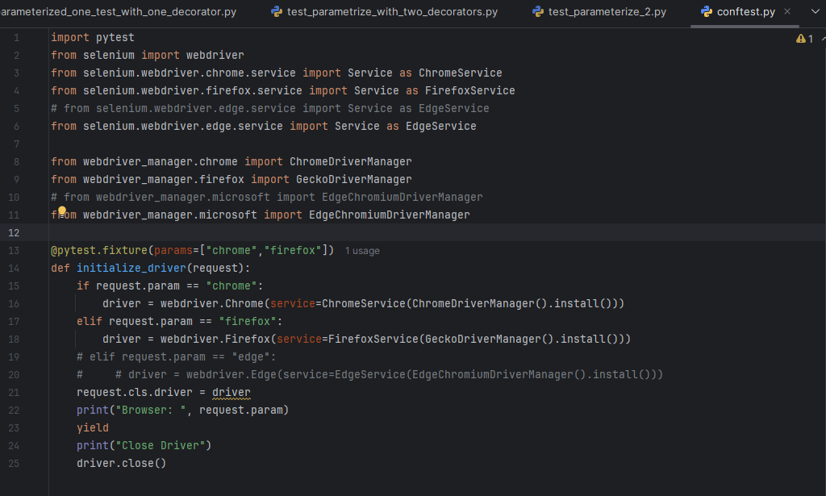

**Fixture content remove from the below mentioned file(test_parameterizex_2.py):**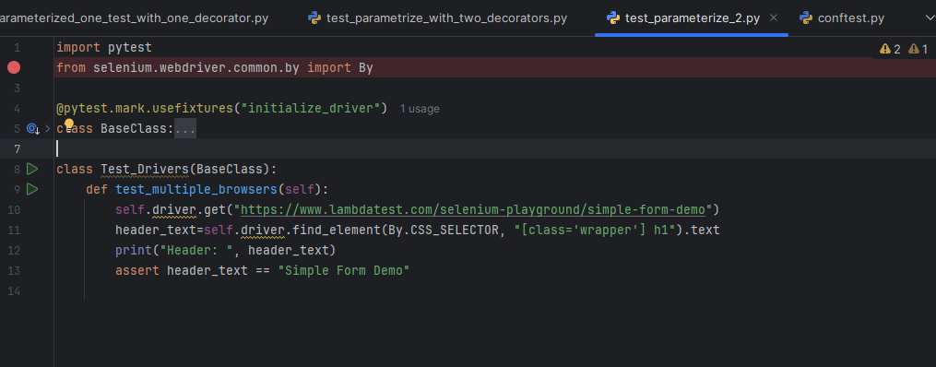

**PYTEST SKIP TEST LOGIC**

**CODE BASE**

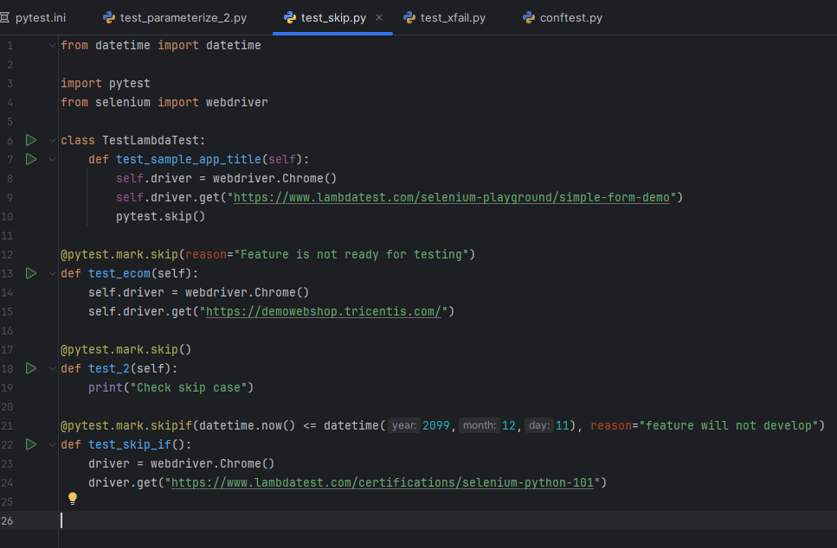

**OUTPUT OF THE ABOVE CODE**

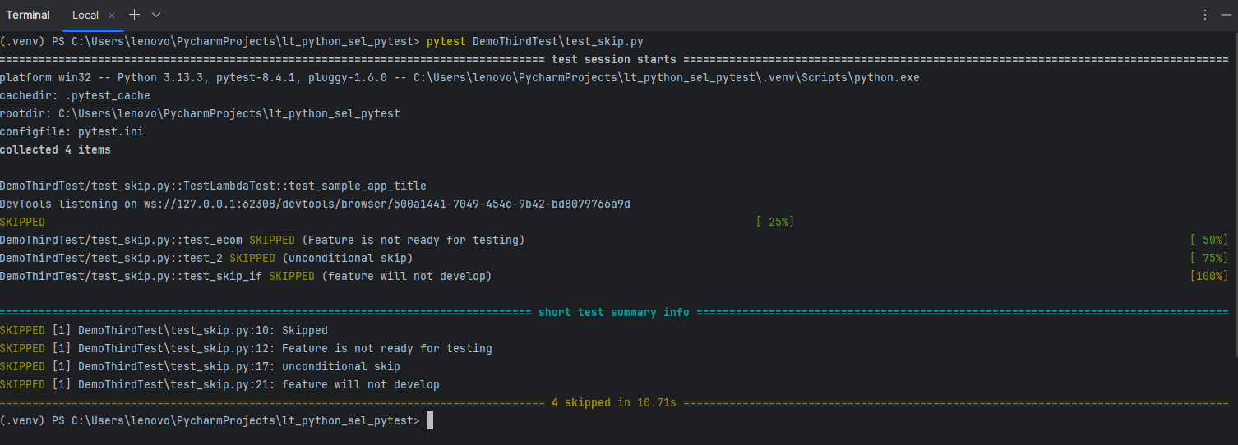

1. **If we pass pytest.skip in the function then it just skipped thefucntion without sharing the information inthe logs**
2. **If we use @pytest.mark.skip(reason=”feature is not ready for testing”) decorator that info. Will print in the report logs.**
3. **If we @pytest.mark.skip()this case it will print this   
   DemoThirdTest/test_skip.py::test_2 SKIPPED (unconditional skip)**
4. **If we use**
   1. @pytest.mark.skipif(datetime.now() <= datetime(2099,12,11), reason="feature will not develop")

**Output: DemoThirdTest/test_skip.py::test_skip_if SKIPPED (feature will not develop)**

1. **Pytest.xfail EXAMPLES**

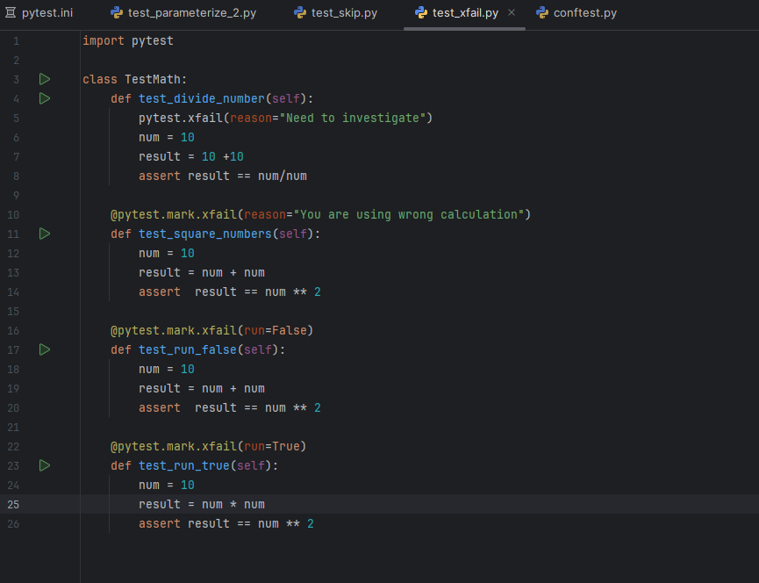

**OUTPUT:**

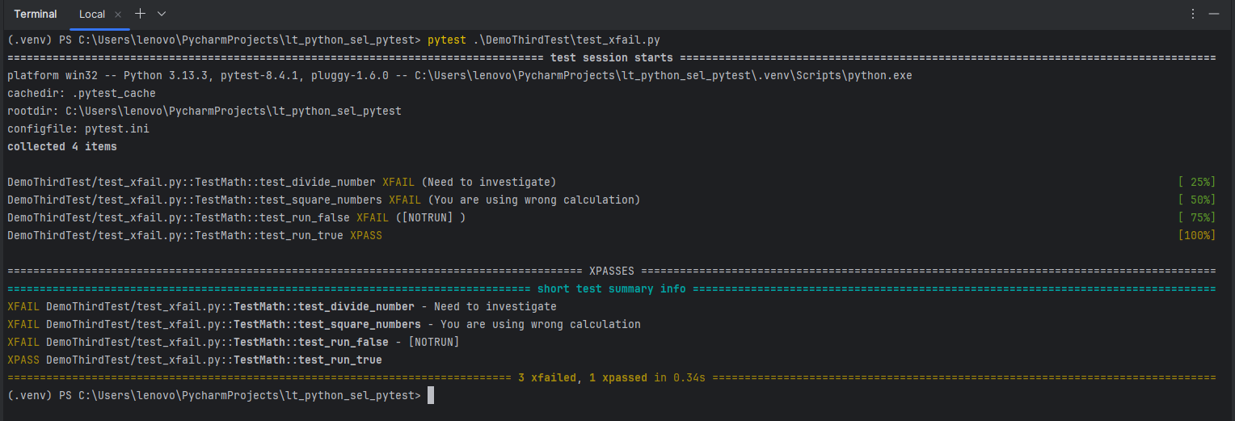

**SKIP THE COMPLETE CLASS**

**@pytest.mark.skip(reason=”skip the whole class”)**

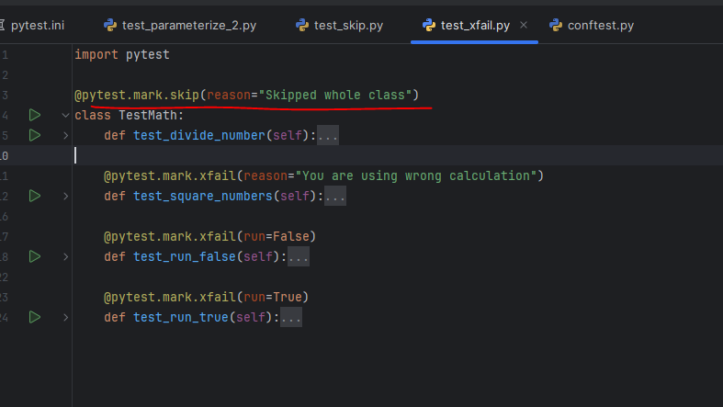

**Output**

**================================================================================= short test summary info =================================================================================**

**SKIPPED [1] DemoThirdTest\test_xfail.py: Skipped whole class**

**SKIPPED [1] DemoThirdTest\test_xfail.py:11: Skipped whole class**

**SKIPPED [1] DemoThirdTest\test_xfail.py:17: Skipped whole class**

**SKIPPED [1] DemoThirdTest\test_xfail.py:23: Skipped whole class**

**XFAIL EXAMPLE**

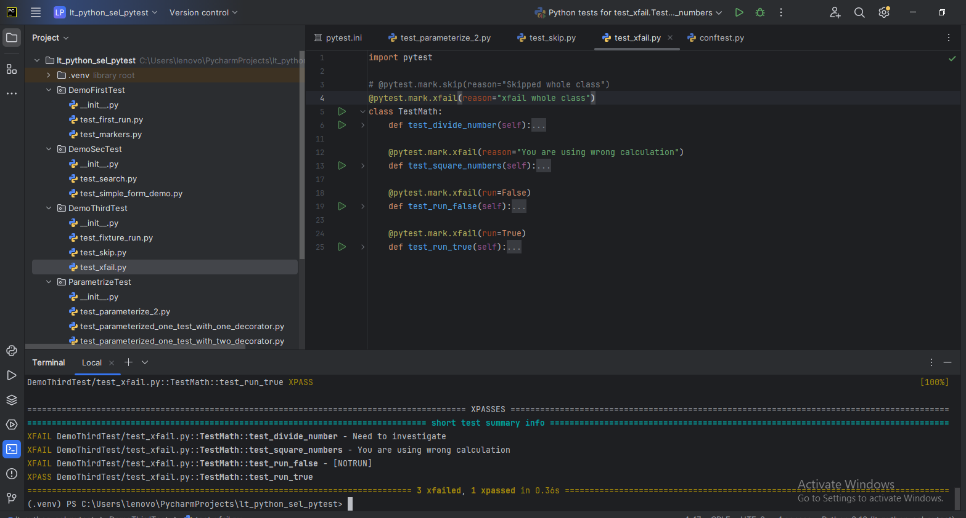

**STOP THE TEST AFTER TEST FAILURE  
USE THEE FOLLOWING COMMANDS  
(.venv) PS C:\Users\lenovo\PycharmProjects\lt_python_sel_pytest> pytest .\DemoThirdTest\test_stop.py --maxfail=1**

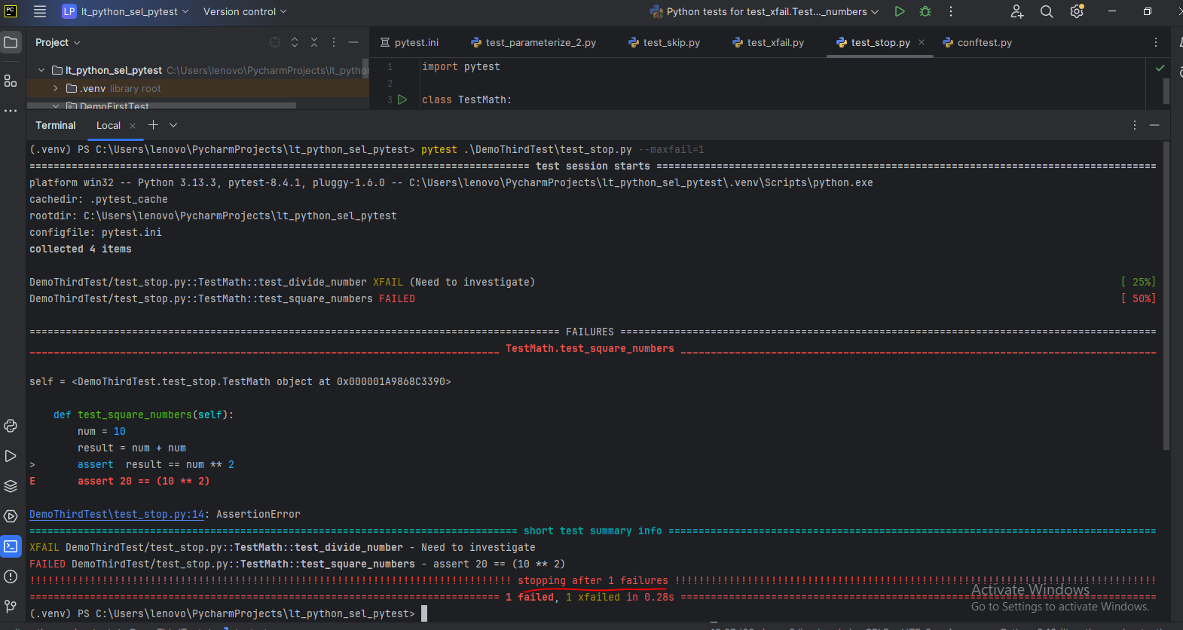

**======================PAGE OBJECT, TEST CLASS AND UTILITIES==============**

1. **First we need to create 3python packages for pages, tests and utilities**
2. **Create base_page.py file under the pages python packages. It used to store all the common function that are used in the all the page objects classes**
3. **Now create a common methods and initialized the class and driver**

**base_page.py**

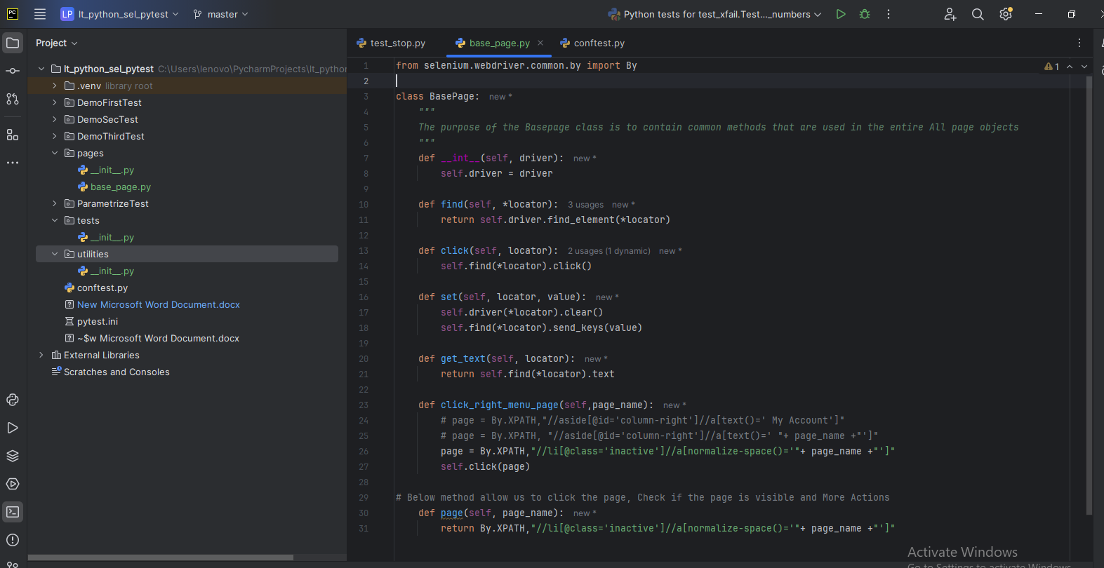

from selenium.webdriver.common.by import By  
  
class BasePage:  
 *"""  
 The purpose of the Basepage class is to contain common methods that are used in the entire All page objects  
 """* def __int__(self, driver):  
 self.driver = driver  
  
 def find(self, *locator):  
 return self.driver.find_element(*locator)  
  
 def click(self, locator):  
 self.find(*locator).click()  
  
 def set(self, locator, value):  
 self.driver(*locator).clear()  
 self.find(*locator).send_keys(value)  
  
 def get_text(self, locator):  
 return self.find(*locator).text  
  
 def click_right_menu_page(self,page_name):  
 # page = By.XPATH,"//aside[@id='column-right']//a[text()=' My Account']"  
 # page = By.XPATH, "//aside[@id='column-right']//a[text()=' "+ page_name +"']"  
 page = By.XPATH,"//li[@class='inactive']//a[normalize-space()='"+ page_name +"']"  
 self.click(page)  
  
# Below method allow us to click the page, Check if the page is visible and More Actions  
 def page(self, page_name):  
 return By.XPATH,"//li[@class='inactive']//a[normalize-space()='"+ page_name +"']"

1. **Now create a test_data.py file under utilities python package**
2. 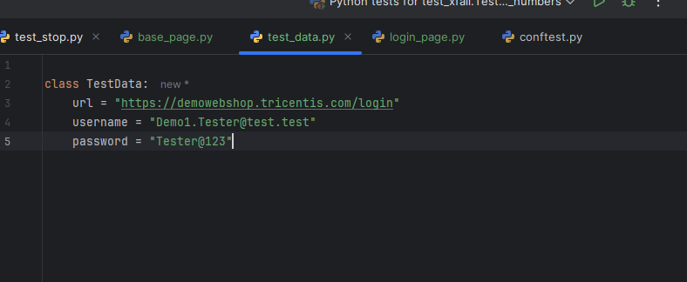

**Now added more locators in the login page**

from selenium.webdriver.common.by import By  
  
from pages.base_page import BasePage  
  
class LoginPage(BasePage):  
 email_address_field= (By.ID,"Email")  
 password_field= (By.ID,"Password")  
 login_btn = (By.XPATH, "//input[@value='Log in']")  
 warning_msg = (By.XPATH,"//span[contains(text(),'Login was unsuccessful. Please correct the errors ')]")  
  
 def __init__(self,driver):  
 super().__init__(driver) # if we do not use the super class or Basepage class we need write the complete code like this  
 # "self.driver.find_element(email_address_field).send_keys(email_address)"  
  
  
 def set_email_address(self,email_address):  
 self.set(self.email_address_field, email_address)  
 # self.driver.find_element(email_address_field).send_keys(email_address)  
  
 def set_password(self,password):  
 self.set(self.password_field,password)  
  
 def click_login_button(self):  
 self.click(self.login_btn)

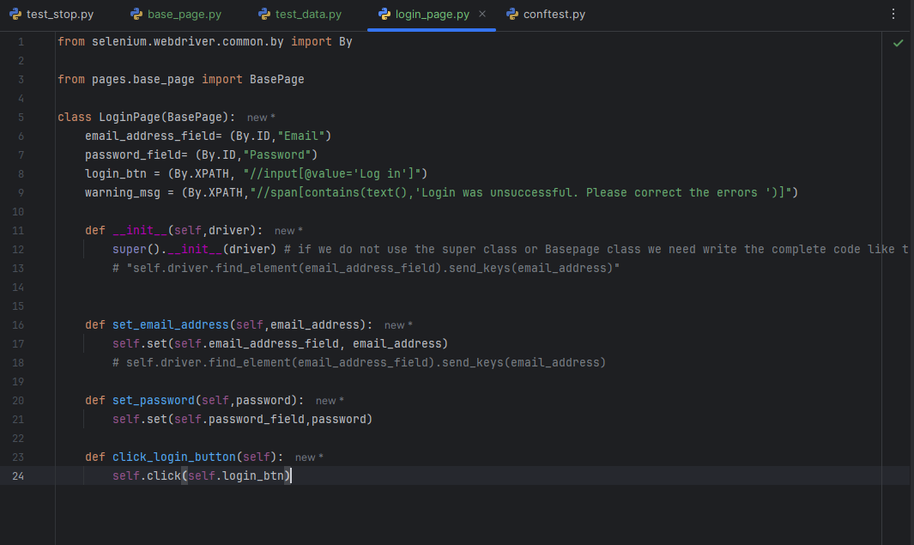

**MiSSING AREA NEED TO ADD HERE**

**LOGIN_TEST.PY FILE AND OTHERS RELATED UPDATES**

**======HTML REPORT**

**INSTALL: pip install pytest-html**

**Command line: pytest test_login.py --html=testreport.html**

**It will generate the report under the test folder.**

**Also, you can update the pytest.ini file it will works for the entire project**

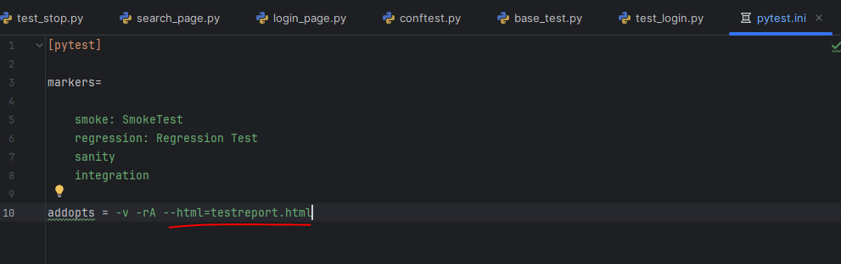

**=========ALLURE REPORT============**

**INSTALL ALLURE REPORT PACKAGE**

**Pip install allure-pytest**

**Pytest testfile name.py –alluredir=AllureReport**

**To convert or presentable form of the allure json and txt file we NEED TO USE ALLURE COMMAND LINE PACKAGE WHICH WE CAN INSTALL FROM THIS LINK:**[**https://repo.maven.apache.org/maven2/io/qameta/allure/allure-commandline**](https://repo.maven.apache.org/maven2/io/qameta/allure/allure-commandline)

**THEN DOWNLOAD THE LATEST ZIP FILE AND EXTRACT AT YOUR LOCAL SYSTE,**

**GO TO BIN FOLDER COPY THE PATH AND SET PATH IN TO THE ENVIRONMENT VARIABLES**

**After tht run following command to generate the allure report and report stored into the**

